Project Report Template

Mobile App Development

1. Project Title
App Name: “In Gauge”: Mechanic Finder App
Team Members:
Fahad Tariq, 261936903 | Muhammad Ibrahim Mughees, 261945643
Course: Mobile App Development | Instructor: Miss Umber Nisar
Date: 1st December 2025

2. Overview
Objective: Build a flutter mobile app to connect customers with nearby mechanics, track job progress, and facilitate communication.
Platform(s): Flutter for Android.
Tools: Flutter, Firebase, Android Studio, Visual Studio Code.

3. Features
Feature | Description | Status
User Authentication | Login and registration using Firebase Authentication. | Implemented
Chat Functionality | Real-time chat between customers and mechanics. | In Progress
Mechanic Search | Locate nearby mechanics. | Implemented
User Profile Management | Update user details and preferences. | Implemented

4. Screenshots/UI
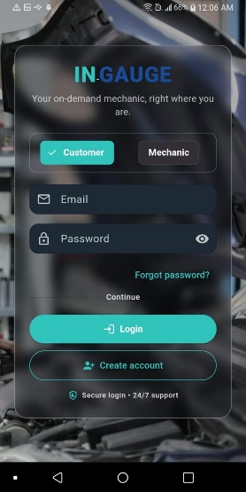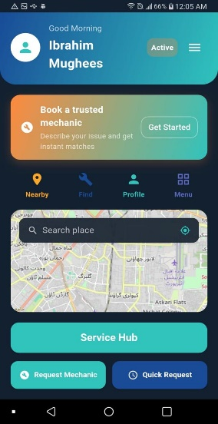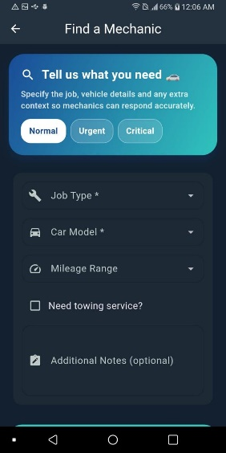
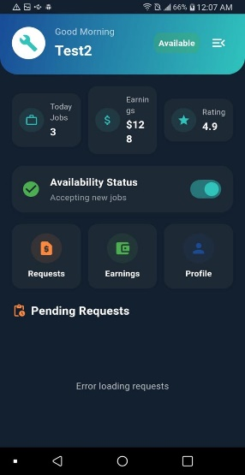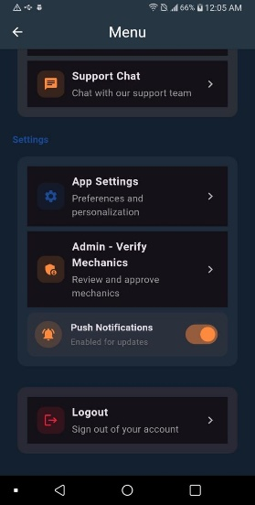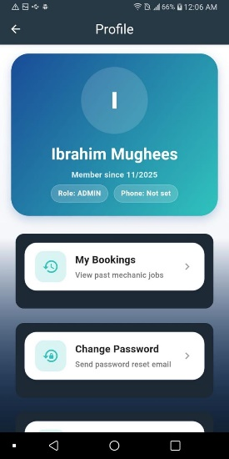

Design Choices:
- Modern, user-friendly interface with responsive layouts.
- Consistent colour scheme and typography for branding.

5. Tech Stack
Frontend: [Flutter/Dart ].
Backend: Firebase (Auth, Firestore).
API: Simple Osm viewer for map,

6. Challenges & Solutions
Challenge | Solution
Firebase Authentication Integration | Used FirebaseAuth package for seamless login and registration.
State Management | Leveraged Flutter's Stateful Widget for managing UI state.
Real-time Communication | Implemented Firebase Firestore for real-time chat functionality.

7. Learning Outcomes
- Developed expertise in integrating Firebase services, including Authentication and Firestore, to build dynamic and scalable applications.
- Enhanced proficiency in designing intuitive and responsive user interfaces using Flutter.
- Strengthened problem-solving skills by addressing platform-specific challenges and debugging complex issues.
- Gained hands-on experience with Git for version control and collaborative development.

8. Future Work
- Add push notifications for job updates and chat messages.
- Optimize app performance for low-end devices.
- Implement offline mode for job tracking.
- Add payment gateway integration for seamless transactions.

9. Links
GitHub Repo: https://github.com/IbrahimMughees1801/mobapp_proj

10. Conclusion
Summary: "In Gauge" is a cross-platform mobile app designed to connect customers with mechanics, track job progress, and facilitate communication. The app has been tested on Android, ensuring a smooth user experience.
Team Contribution:
- Ibrahim Mughees: Led the development, including Firebase integration, UI design, job tracking logic, and overall project management.
- Fahad Tariq: Assisted with UI, Firebase authentication and testing.

11. Declaration
We confirm this is our original work.
Signatures:

Date: 1st December 2025

Attachments
Code snippets:
1)From main.dart
class AppRoot extends StatelessWidget {
const AppRoot({super.key});

@override
Widget build(BuildContext context) {
return StreamBuilder<User?>(
stream: FirebaseAuth.instance.authStateChanges(),
builder: (context, snap) {
return Consumer<ThemeProvider>(
2)From mechanic menu screen:
class _MechanicMenuScreenState extends State<MechanicMenuScreen> {
bool _availabilityLoading = true;
bool _available = true;
bool _notifLoading = true;
bool _notificationsEnabled = true;

Example Test Case: Test Case: Firebase Authentication - Successful Login
Explanation:
This test case verifies the Firebase authentication system by simulating a successful login. The app is launched, and valid credentials (e.g., test@example.com and password123) are entered into the email and password fields. Upon tapping the "Login" button, the app communicates with Firebase to authenticate the user. If the credentials are valid, the app navigates to the HomeScreen, confirming successful login. This test ensures proper integration of Firebase authentication, validates input handling, and confirms seamless navigation, which are critical for the app's core functionality.

Test Case: Invalid attempt:
This test case verifies the app's behavior during a failed login attempt. The app is launched, and invalid credentials are entered into the email and password fields. Upon tapping the "Login" button, the app communicates with Firebase to authenticate the user. Since the credentials are invalid, the app displays an error message, such as "Login failed." This test ensures that the app handles authentication errors gracefully, provides appropriate feedback to the user, and prevents navigation to the HomeScreen when login fails.

